Industrial Year Report

Aberystwyth University Information Services, Industrial Year

18th September 2012

Mathew Teague

**Contents**

**Introduction** 1

**Organizational Environment** 1

History of Aberystwyth University 1

Aberystwyth University and Departments 1

Information Services Department 3

Business Information Systems 3

Customer Services 3

Workshop 3

Development 4

System Support 4

Network and Telephony 4

Welsh Video Network 4

My Team and Me 4

**Technical and Application Environments** 5

Customers 5

My Work Environment 5

Applications & Software 5

Sunrise 6

Microsoft Web Access 6

Microsoft Outlook 2010 6

Reg 6

Remote Assistance 6

Interzone 6

Astra 7

Trillian 7

SharePoint 7

SharePoint Designer 2007 7

Pcounter 7

Circulation 8

Printing Server 8

Primo 8

**What I Did** 8

Weekly Routine 8

Mail Support 8

Telephone Support 8

Help Desk 9

Printer Support 9

Task Shift 9

Extra Duties 10

Main Projects 10

Evening Shift 10

Group Activations 11

Library 11

Training 11

**Critical Evaluation** 11

**Bibliography** 13

# **Introduction**

For my Industrial Year I obtained a position with Customer Services, a team within Aberystwyth University’s Information Services (I.S.) department. I worked with Customer Services from the 1st July 2011 to the 31st July 2012. I.S. is made up of several teams, with each team having different duties to support Aberystwyth University’s main computer facilities, libraries and network facilities for its students, staff and the public visiting the university.

Due to this, they hired five industrial year students including myself, to help the team support the facilities. Two of the students were placed within the Workshop team which supported the university’s teaching rooms, while providing maintenance and repair services to PCs.

# **Organizational Environment**

## History of Aberystwyth University

Aberystwyth University first began in 1867, when the Welsh University committee led by Hugh Owen purchased the Castle Hotel from a Thomas Savin. The Castle Hotel would later become Aberystwyth University, however it is now known as Old College. Aberystwyth University went on to become the first ever university in the world to create a chair of Welsh History. (*Aberystwyth University Website, 2012*)

1965 saw the university exceed 2000 students for the first time since 1867. Over the years the university gradually moved from the sea and up the hill, with several new departments being created with in the meantime. In 2010 Aberystwyth was rated 6th across the United Kingdom for best student experience (*Aberystwyth University Website, 2012)*.

## Aberystwyth University and Departments

Currently Aberystwyth University consists of three campuses, Old College and around eleven thousand students with fifty seven departments. These include non-academic and academic departments, each having their own sub departments, teams and hierarchy structure. Each department has the same hierarchical structure, as shown in Figure 1 (*Wikipedia List of Academic Ranks, 2010*).

The main campus of the university is where the majority of the students and staff lectures will take place. It is also where the majority of departmental buildings are, and where the heads of departments will be situated.

The university provides each department with use of a computer network and computer facilities. The computer facilities would include a number of computer rooms throughout all three campuses and Old College, for the use of the academic department’s students. Each of the computer room grants students access to use the internet and the university’s network, with some rooms allowing access to the university’s wireless internet. However in the highly used computer rooms there is extra equipment for the students and staff to use such as printers, scanners, laptop ports, group study areas etc.

However even though Aberystwyth University provides computer rooms for students, some of the departments will have their own computer rooms, only giving access to students and staff who are a part of that particular department.

*Figure 1 University Hierarchy*

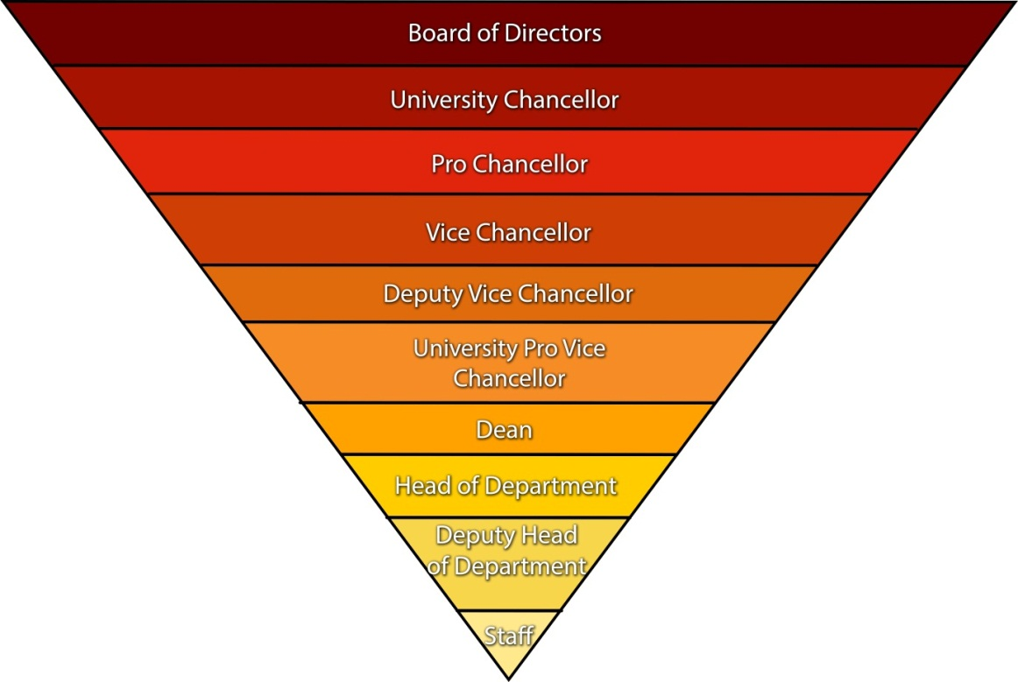

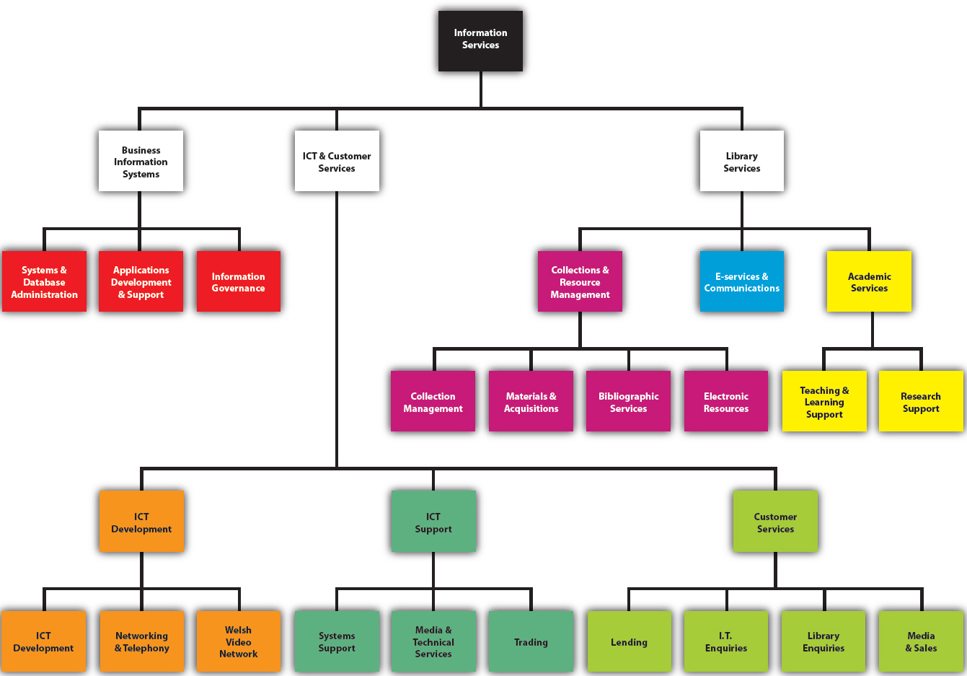*Figure 2 Information Services Department Structure*

## Information Services Department

I.S. is one of the non-academic departments that make up the university. I.S. has its own departmental structure, hierarchy of staff and is broken up into several teams. The department is broken down into three sub-departments: Business Information Systems, ICT and Customer Support, and Library Services. These three sub-departments are then broken down even further into various smaller teams, each one having their own roles and responsibilities. This structure of I.S. can be seen in Figure 2.

The main role of I.S. is to maintain and support the facilities for Library Services, research and teaching facilities, while supporting the university’s IT Services. Some examples of IT Services supported are: the university’s file stores (personal and shared), university network, computer facilities, systems, and user’s accounts.

I.S. relies on its teams acting as first, second and third lines of support to ensure the departments run efficiently and provide the best support for its customers. The first line of support would be the team who meet the customer face to face or talk to the customer on the phone. The first line of support team would then take all the information about the query of the customer and pass on all the information to the relevant team. For example if a customer‘s internet problem could not be fixed it would be passed to the Network and Telephony team. However if the problem was too difficult or complicated the problem would be referred to the either the second or third line of support. The third line of support would not really deal with the customers.

While I was working with I.S. the main teams that I worked with and referred jobs to were Development, System Support, Workshop, Media & Sales, Network & Telephony, Business Information Systems and Welsh Video Network.

### Business Information Systems

Business Information Systems is also known as BIS, who are responsible for building and sustaining information system of the university. This includes maintaining the main database which controls Aberystwyth University’s student record, and university payrolls.

### Customer Services

Customer Services has the responsibility of dealing with customers face to face, over the phone and by email. The Customer Services team is made up of four separate teams as shown in Figure 2. The Customer Services team are the frontline of support and provide help to students, staff, visiting staff, visiting students and members of the public. The library team deal with library enquires.

Media & Sales is the fourth team of Customer Services, as shown in Figure 2. Their primary role is to supply customers with computer consumables such as CDs, DVDs, USBs, Ethernet cables etc. However, Media & Sales also loan equipment to customers, as well as providing special printing such as A3 printing and binding of dissertations.

### Workshop

The Workshop is a team of technicians that support teaching rooms, teaching facilities, maintenance and repair of PCs and other electronics. The Workshop’s full name is Media & Technical Services, which is displayed in Figure 2. The Workshop team deal with more complicated computer problems, such as hardware issues and advanced computer viruses. The Workshop team fix any faults that might occur in teaching rooms.

### Development

The Development team support, maintain and design most of the software that ICT and Customer Services use. Some of the software which they maintain and support is Interzone, Webmail, Microsoft Exchange and My Account.

### System Support

This team has the role of supporting the university’s servers. The team also support Aberystwyth University’s network. For example if a customer has lost work on their personal file store, System Support would recover the file/files and place them back into customer’s file store. The team would also be assigned jobs if a university user is having problems with their account, such as their password is not working even after it’s been changed.

### Network and Telephony

The Network and Telephony team have two main roles: supporting and maintaining the university’s network, as well as supporting the telephony system. Within the Network part of the team there is another sub team known as Stunet. This sub team would deal with student internet issues such as installing Ethernet ports. Despite there being a sub team, the members of staff share jobs. The role of the Telephony is supporting Aberystwyth staff with telephone issues, for example installing new phones.

### Welsh Video Network

The Welsh Video Network team are part of Development; their responsibility is to support the university’s video conferences. They support any video conferencing problems that ICT Enquires cannot help with. The team also had an industrial year student, who would work with ICT Enquires every Friday.

## My Team and Me

When I started my industrial year placement, the team that I was working with was ICT Enquires, a sub team of the Customer Services (shown in Figure 2). The ICT Enquires team (also referred to as IT Support) consists of six full time members of staff, three industrial year placements, four casual staff and one Welsh Video Network industrial year. The casual staff would also cover the ICT Enquiry helpdesk on Friday evenings and weekends. Some of the roles of ICT Enquires are: supporting customers face to face, supporting users on phone via remote assistance, answering customer email queries.

Since Customer Services joined with the library services, my team ICT Enquires began to share responsibilities with the Lending and Library Enquires team.

Customer Services deal with the frontline of enquires and refer jobs onto other teams within I.S.. There are various customer support duties that ICT Enquires undertake without referring on to the other teams, these include: minor virus and spyware problems, Microsoft Office difficulties, printing issues, internet setup difficulties.

Throughout the weeks I would be timetabled to do printer support. This is explained in further detail in the third section of this report.

During the university’s term time I was also scheduled to work the late shift. The late shift involved instead of working my normal hours of nine am till five thirty pm, I would work from one pm to seven thirty pm.

# 

# **Technical and Application Environments**

The technical environment for I.S. consists of: dealing with customers, several applications, providing software and hardware support while working in an organized, busy environment.

## Customers

The customers that I.S. deal with are mainly Aberystwyth University staff and students; however there were queries from students at other universities. I.S. also dealt with people from other organisations, companies and the general public. The issues and inquiries that were normally asked by staff included password changes, account creating etc. The majority of queries from students were changing passwords, unlocking accounts and renewing library books.

## My Work Environment

Customer Services was a relaxed work environment which allowed all of us to talk freely to each other whilst remaining focused on our duties and supporting the customers. During the week I would often remote into the printer server from my PC.

Within the ICT Enquiries office there are nine desks. There is also another office joined to ours, which is for ICT Enquiries’ supervisor and the library supervisor. Situated around the ICT Enquires office t are a number of Ethernet ports which are used for testing and to be used as spares in case extra are needed within the office.

Within the office there was an FAQ computer which ran Microsoft Windows XP, Vista and 7.This PC had all three of the latest versions of Microsoft Windows, because it allowed ICT Enquires to troubleshoot user problems and to test on multiple operating systems. However, it was mainly used for creating ‘Show Me FAQs’, and as a spare computer.

I was given a desk, and computer which ran Microsoft Windows 7 Enterprise 32bit and had 2GBs of RAM installed. Half way through the year the computers became very slow and started to struggle with basic tasks. Our computers were given an extra 2GBs of RAM, so that they have 4GBs of RAM and the option to upgrade the 32bit version of Windows 7 Enterprise to the 64bit version. However due to how busy Customer Services is I never found the time to upgrade my computer to the 64bit version. Being administrators of the PC we were allowed to install any software that would help us support customers easier and locate information quicker. Such software I installed was Circulation, PCounter and Share Designer 2007.

During the early parts of my industrial year my work environment became under pressure when the Development team began transferring staff accounts from Webmail over to Microsoft Exchange. To help us with the tasks of supporting situations like these, the ICT Enquires office has a tambour which holds equipment for staff to use, to troubleshoot and use in a disaster. Some of this equipment included: an Apple Mac which runs Apple OSX 10.7 Lion, Toshiba Satellite laptop running Microsoft Windows 7, Orange dongle, software, USB Ubuntu 11.04 Natty Narwhal operating system and an Orange mobile.

## Applications & Software

Working for I.S. required the use of many applications and software. Each piece of software had its own role within I.S. and was essential providing help to customers. There was some software that was more essential than others and needed to be used on a daily basis. The most essential software that Customer Services uses is Sunrise, Interzone, Reg, Microsoft Outlook, Microsoft Web Access, Printing Server and Microsoft Remote Assistance. These pieces of software are the crucial applications that I.S. rely on.

### 

### Sunrise

Sunrise is a piece of software purchased by I.S. that allows ICT and Customer Services staff to submit faults, keep track of faults reported to other teams. Some of the faults that are reported through Sunrise are: networking, printers, hardware faults, VOIP phones and software installation.

When a Sunrise call has been created a reference number is assigned to that call by Sunrise. Sunrise also allows ICT and Customer Services staff to be able to leave updates to the call and a full call history, this shows what has been done and what updates have been left. Once the Sunrise call has been completed and then closed by a member of staff, another automatically generated email sent to the customer informing them that the call has been resolved and what has been done.

### Microsoft Web Access

Microsoft Web Access (a web version of Microsoft Outlook) is only used by staff, it is also known as Exchange. Web Access allows users to assign trip notes to their account, view emails etc. Microsoft Web Access is also used for testing by ICT Enquires if a customer reports they are having problems with a feature in Microsoft Outlook. Towards the end of my industrial year all staff on Exchange 2007 were being upgraded to Exchange 2010 and Exchange Web Access became Outlook Web Access.

### Microsoft Outlook 2010

Microsoft Outlook was the main email handler used by I.S. and the majority of the university staff. During my industrial year we used Outlook 2010 to provide email support to customers. Microsoft Outlook would have more than one email account within it, for example emails from customers would go to a separate email account.

Outlook 2010 was also used to view important updates from other I.S. departments for example any network changes that were going to happen. Half way through my industrial year I.S. started to upgrade all of the other university departments from Microsoft Outlook 2007 to Microsoft Outlook 2010.

### Reg

The application Reg was created by the Development team and was part of university’ MyAccount applications, for ICT and Customer Services. The main use for Reg was to manage user’s accounts for example checking a user’s information, resetting passwords, locking and unlocking accounts, activating user accounts, extending account end dates and merging accounts.

### Remote Assistance

ICT Enquires uses two remote assistance applications to support telephone customers at home from the office. The remote assistance allows ICT Enquires to access a customer’s PC from the office without being at the PC. The two remote assistance applications that ICT Enquires use are Windows Remote Assistance and ShowMyPC. Remote assistance was a key support tool that ICT Enquires used when I joined the team. For members of staff requiring telephone support, ICT Enquires would use Windows Remote Assistance, as long as the member of staff was on the university network.

ShowMyPC was the other remote assistance application used by ICT Enquires. ShowMyPC is used when a customer not on the university network and requires telephone support. The application is also sometimes used when Windows Remote Assistance does not connect.

### Interzone

Interzone is another web based application that was developed by the Development team. Interzone is used to manage and monitor devices registered on the university network. It allows ICT Enquires, Network and Telephony teams to view, manage, add and remove registered devices such as laptops and handheld devices on the university network. Interzone shows the MAC address of each device for wireless and LAN cards as well as displaying the device owner’s username and the departments VLAN the device is registered to.

Once a device has been successfully registered on Interzone the device is given an IP address which allows the user to connect to the network, using their Aberystwyth username and password. Due to Interzone providing these details, Interzone is also used to test devices if there are having difficulty connecting to the network. Interzone will show when the device last connected or hasn’t connected to the network and if they are receiving a DHCP lease.

### Astra

This application is used by the library teams and ICT Enquires, but is managed by the BIS team. Astra shows all the university information of a user. The library supervisors use Astra to create temporary account or extended an accounts access. Once information has been entered into Astra, Astra will update the information on Reg. It also allowed ICT Enquires team to access extra information about a customer which is not on Reg.

The library team and ICT Enquires also used Astra for creating and printing out new ‘Aber Cards’ for university staff, students, visiting students and visiting staff. However Astra is not just used by I.S. it is also used by lots of other departments within Aberystwyth University. Unlike I.S. other departments have different permissions and cannot access the same information that I.S. can.

### Trillian

Trillian is a multiple instant messaging (I.M.) software that allows more than one I.M. client to be added to it. When I joined ICT Enquires they were using Windows Live Messenger and Seesmic to support customers using MSN and twitter. However my supervisor wanted a piece of software that can manage both in one client. For one of my tasks I installed and setup Trillian for ICT Enquires to use, which put all their messaging clients into one.

### SharePoint

This is a web based application that allows I.S. and other departments to create and store documents, pictures and files on the network, without having to have a shared drive. SharePoint then allows one person to check out a file to edit and upload or allow multiple people to edit a file. ICT Enquires used this to store its procedures so that if a member of staff didn’t know what to do for a particular job they could go onto SharePoint and look at the procedure.

### SharePoint Designer 2007

SharePoint Designer 2007 is a free application that ICT Enquires uses to create and edit FAQs. SharePoint Designer 2007 is very similar to Microsoft FrontPage and early Dreamweaver software. To edit the FAQs SharePoint Designer allows the user to download the inf.aber.ac.uk/FAQs site into it. SharePoint Designer 2007 updates changes made to a FAQ page instantly.

### Pcounter

Pcounter is an application that is used by Customer Services, allowing staff to see how much printer credit a staff or student has and their printing details. It also allows Customer Services staff to refund a customer’s credit if there has been a problem with printing a document, or the printer has failed to print the document but still charged the user.

### 

### Circulation

Circulation is software that shows all the details about a user’s library information and access. It shows for example how many books a user has on loan, the book’s due dates, if the user is a distance learner or scounal user and when their library access expires. Circulation allows Customer Services to charge and discharge library items on a customer’s account.

### Printing Server

When working with Customer Services I used the printing server to monitor the status of the printers and check if a printer needed assistance. We would mainly check to see if a printer had a paper jam, toner or imaging unit needed replacing and if paper needed re-filling. The print server ran on Windows Server 2003 and would normally be accessed by remote desktop connection.

### Primo

Primo is the online e-library web application used by the university. At the beginning of my industrial year the e-library application was called Voyager however it was starting to be replaced with an updated application called Primo. Primo shows the university library catalogue and the journals it subscribes to. It also allows users to check to see if a book is available to take out and which university library the book is in.

# **What I Did**

The main five duties which I was assigned to during the year were: help desk, telephone support, mail support, tasks and printer support. As well as these duties I was also scheduled to do other duties and attend training.

## Weekly Routine

### Mail Support

As part of my industrial year placement with I.S. I was timetabled to support customers via emails and instant messaging. When scheduled on the mail shift I would work from my desk, however I would also work on emails while on printer support out of term time. The mail shift role was to work on the oldest emails first and work the way to the newest. I would also support customers by logging into Trillian and answering queries on MSN, Yahoo and Twitter. I also had to sign into the I.S. Facebook page, to check if there were any queries posted on Facebook.

Another responsibility that I had was checking I.S. forms had been correctly completed and created. Some of these forms were: IS Access forms, Office Account forms and Temporary Course Account forms. If the mail shift became quiet we would then help with telephone support.

### Telephone Support

My industrial year also included me supporting customers on the telephone. The telephone shift allowed me to work from my desk by using a VOIP 7911 phone which I could log into with a personal number and the Customer Services number. While on the telephone shift I would have to deal with a number of calls, computer and none computer related.

A large amount of the calls would be from distant learning students, distant staff and retired staff. A lot of calls would be re-directed to other teams or departments that had come through to ICT Enquires. The majority of calls that came through were customers who had computer difficulties such as: hardware failures, email queries, software faults, instructions and network issues. I would also have to deal with lectures wanting to book computer rooms and customers wanting to know about software sold by the university and video conferences.

During term time there would be a lot of calls for resetting account passwords, renewing library books and network setup, however some calls that were hard to understand the fault required remote assistance to be used. Remote assistance would be program most used with telephone support and the first choice of software.

The telephone shift would also require checking the answer phone messages however at the end of my industrial year a different answering message was created, which resulted in very few answering messages being left if none at all. One of the most difficult aspects of the telephone shift was not knowing which team to Sunrise the call to, especially if I couldn’t recognise the problem they were having.

### Help Desk

The help desk shift was the third most important duty while working for Customer Services. The university had two help desks one in the Hugh Own Library, on the main university campus and the second in the Thomas Parry Library. I was timetabled to work on the Thomas Parry help desk once a week, however shortly after starting Customer Services; support for the Thomas Parry help desk was stopped due to the library not being used very much.

When working on the help desk we had to fill in a statistics sheet for every customer. The statistic sheet consisted of four columns A directions, B under thirty minutes, C over thirty minutes and None IT related.

While on the help desk there would be a lot of queries from customers, such as network difficulties, computer faults, email difficulties, virus removal, spyware removal and computer questions etc. We would also deal with members of the university, from staff to retired staff and students to part time students. We would also support members of the public, but could only provide limited support. Some of the most challenging parts were dealing with foreign exchange students, as it was very difficult to explain the problem with the computer due to language barriers.

The help desk also had two other duties and one non-official duty. The first duty was transferring the statistics from the statistic sheet to a Microsoft Excel statistic document. This would mainly be done by the person who was timetabled to be on the help desk in the morning. If the help desk was quiet, a further duty was to work through the FAQ reporter which involved checking FAQs to see if any needed updating or fixing. If the FAQ reporter was completed, the next task to do during quiet periods would be to support email enquiries.

### Printer Support

During the week I would be timetabled to support the printers managed by I.S.. While on printer support I would have to remote into the print server, which would show me the status of each printer. The responsibilities of printer support included: re-filling the printers if they had no paper, replacing imaging units, toner cartridges and dealing with minor issues such as paper jams.

Every two weeks we would also be timetabled to do a printer run. The printer run was slightly different to normal printer support and it would only timetabled for the morning. The purpose of printer run was to visit all of the printers supported by I.S., making sure they were all functioning correctly and they were fully of paper. You would also have to collect the money from the printer credit machine in the Old College Library.

When out of term time printer support became a more relaxed duty as the printers were not being used as much. This resulted with printer support being combined with the mail shift.

### Task Shift

The task shift was the fourth main weekly task that we were timetabled to do. During the task shift I would have to work on and complete tasks that had been assigned to me. I would also have FAQs that I would need to create or edit along with checking the FAQ reporter. The FAQ webpages were created by the System Support team, which is a database driven website with a large amount of content within it.

Some of the FAQs that I worked on were creating instructions on how to connect to the university’s network via a Kindle Touch. The initial instructions came from Lancaster University however I then changed them to fit with Aberystwyth. Another FAQ which I created was how to use OpenBook 9. This is a piece of software that allows people with visual impairment and learning difficulties to scan and edit documents. The software would also read out loud the document they have scanned. At the beginning of my industrial year I was also given an FAQ to describe and inform members of staff about Information Monitors. For this FAQ I had to liaise with a member of the Development Team so that I could learn about Information Monitors to write the FAQ.

As well as completing FAQs I was also assigned tasks to create and complete. I was assigned two main tasks as well as minor tasks. Some of the minor tasks were re-creating the help desk queue signs, creating a new I.S. logo for the Aberystwyth website, hearing loop testing and hearing loop instructions. For the help desk queue signs I created thirty numbers in Microsoft Publisher, printed them and then I thought to add security stripes on the back of each number. These security stripes would stop people walking out of the library with the numbers.

Due to me being hearing impaired and having a T-Loop device for my hearing aid, I was given the task to test Customer Service’s hearing loops. I would test to see if the hearing loops would respond to my hearing aid and if it would give a sufficient volume level. On my last day of my industrial year I was given the task to create instructions on how for hearing impaired users change to the right channel to pick up the T-Loop function.

## Extra Duties

### Main Projects

As well as the key tasks that I was given, I was also given two main projects. My first main project was to expand Customer Services MSN support. The main objective of the task was to find a program that would let ICT Enquires support customers using several I.M. clients in one overall client. After researching different multiple I.M. clients and looking into their pros and cons I decided to use Trillian for ICT Enquires I.M. client. I then installed the client on each computer in ICT Enquires. Trillian allowed Information Service’s Twitter and MSN account to be added plus an I.S. Yahoo account. The main reason for why I chose Trillian over other multiple I.M. clients was because Trillian had a web version. This web version could then be used if there was a disaster and no one could come into work and also if there needed to be more than two people logged in at the same time.

The second main project I had was creating and adding reminders to a marketing/communications SharePoint document. I was given a list of all the topics that needed a reminder adding to them and the topics that needed to be added to the SharePoint list. Once I added the topic from the list I then added the details and the link to the SharePoint document to the reminder system.

### Evening Shift

Once term started ICT Enquires team was timetabled to do an evening shift every two weeks until term finished. The evening shift would include some one staying to work until 7:30pm instead of 5:30pm. Once the person had done the evening shift they would get two hours in lieu to take when they wanted. While on the evening shift there will be one member of ICT Enquires and one library part time staff. The ICT Enquires staff would be in charge of putting the till away in the safe, making sure equipment that could start fires was turned off and walking around the library counting people for fire safety.

### 

### Group Activations

During my industrial year I would help with group activations. Group activation involved activating accounts with random passwords for international summer students doing summer courses or staff for temporary courses. During the activation we would deal with a person individually, asking for ID then giving them a username and password. Once half an hour had passed, to allow their account to become unlocked, we would then setup and register their devices onto the university’s network.

### Library

While mainly working for ICT Enquires I would also help with minor library duties. I would mainly renew customer’s books, check out and check in books. However I would also help customer with using Primo to find the book they were looking for within the library. I would also help with the library if a customer called to renew books. I would then renew the book by using Circulation.

### Training

Throughout my industrial year I attended several training sessions. When starting my industrial year I attended a full week of training learning about Information Service organisation. During this training week I learnt how to deal with customers, how to deal with particular questions, working in a team etc. We also had official and nonofficial training hours every Wednesday morning.

Some of these training hours were: being trained to use and support equipment that help people with visual impairment, visiting server rooms, library training, network setup, computer room booking, Primo and electronic resources training and EndNote.

# **Critical Evaluation**

When starting my placement I was surprised to find how busy the department was and how nearly all the university looks to Customer Services as their first line of call for any matter, computer and non-computer related. At first I found it quite a shock and difficult, for example during fresher’s week, Customer Services had many people throughout the week requiring assistance. However once I became more experienced and more confident I found working in the department more manageable and something I could cope with better.

Before starting the industrial year placement with I.S. I had skills with dealing with customers, which I had gained from working in catering, computer experience from university and basic IT support from helping friends and family. After completing the placement, I feel I gained knowledge of how to combine both customer skills with IT skills, and I believe I improved my skill and ability with working in a team. I also feel I improved some of my computer knowledge by learning new techniques to solve computer faults. I particularly enjoyed learning about new software such as TCP View which showed what ports a piece of software is accessing. I also enjoyed training about PHP and how to stop people from hacking websites through SQL injection. I feel that I could take all the skills that I have learnt from working with Customer Services to other employment positions not just other IT support positions.

I felt that I had a good relationship with the ICT and Customer Services teams and I found them to be very friendly and would almost always be willing to answer questions that I didn’t know or didn’t feel comfortable with. The best part of my placement was working with the ICT Enquires team because I felt they created a working atmosphere where you could relax and be yourself without worrying about making mistakes. My supervisor made working for ICT Enquires easier to settle into, each person feel that it was ok to ask questions and not be worried.

Throughout the thirteen months of my work placement I discovered how a university organisation works and what procedures have to be carried out to support even the slightest problem. I found that it is crucial for each team to work together when supporting customers and that the hierarchical tree that make up the university needs to be in a state of balance to perform successfully. For example if customers would ring up about the progress of a job they have with another team, we would communicate with the other team for them.

I also discovered that Customer Services relies mostly on paper forms for computing and network applications such as extending account expiry dates and wireless access for events. Several forms are given to Customer Services every day, this can cause problems as the amount of paper received can become lost, have numerous errors or be unreadable. These errors can then cause the customer to become frustrated due to their account not being created or sometimes these errors can become more time consuming when processing the forms.

If I was given the chance to change parts of Customer Services I would cut down the amount of paper forms that Customer Services relies on. To do this I would make the forms electronic but still keeping paper versions for the most important forms, such as account creations and extension of account access. Making the forms electronic would not only organise the forms more efficiently but also cut down the amount of errors and stop forms being unreadable. However by keeping backup paper versions of the most important forms, ICT Enquires can still process the customer request s even if the network were to fail.

After finishing my placement with I.S. I am happy that I accepted the position and that I.S. wanted me to work with them. I really enjoyed the chance to work with customers and help them with their computer queries. However due to my hearing impairment I found the environment sometimes difficult to work in, especially when it became loud or when the fire alarm was being tested. I also found the emergency telephone software difficult to use due to the software and headphones not being clear enough for my hearing impairment. Besides from these two difficulties I really enjoyed the responsibilities and the environment of my placement, due to me being made to feel as part of the team and welcome.

# **Bibliography**

"The University." *Aberystwyth University*. Aberystwyth University. Web. 22 March. 2012. <http://www.aber.ac.uk/en/university/history/timelinepart1/>.

"The University." *Aberystwyth University*. Aberystwyth University. Web. 22 March. 2012. <http://www.aber.ac.uk/en/university/history/timelinepart2/>.

"The University." *Aberystwyth University*. Aberystwyth University. Web. 22 March. 2012. <http://www.aber.ac.uk/en/university/history/timelinepart3/>.

"List of Academic Ranks." *Wikipedia*. Wikimedia Foundation, 26 Mar. 2012. Web. 26 March. 2012. <http://en.wikipedia.org/wiki/List_of_academic_ranks>.

"Information Services." *Aberystwyth University*. Aberystwyth University. Web. 27 March. 2012. <http://www.aber.ac.uk/en/is/about/portfolio/>.

"Information Services." *Aberystwyth University*. Aberystwyth University. Web. 27 March. 2012. <http://www.aber.ac.uk/en/is/about/>.